What is Tennis elbow?
The cause of elbow pain can arise from many areas and structures in and around the elbow joint. It could also be a result of referred pain emanating from the neck or even shoulder. In today’s blog we are going to be covering one of the most common causes of elbow pain, Lateral Epicondylitis, also known as tennis elbow. This condition is greatly associated with your typical repetitive strain injuries that are usually prevalent in the dominant arm. Approximately 1-3% of the general population and 5-15% of the working population are affected, therefore making it the most commonly diagnosed elbow condition.
Let’s take a quick look at the anatomy of the elbow joint
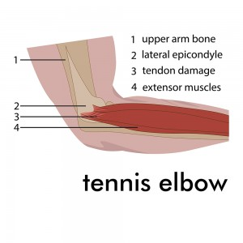 Your elbow joint is made up of 3 bones: your upper arm bone (Humerus) and the 2 bones of the forearm (Radius and Ulna). On the front of your forearms are flexor muscles and on the back of your forearm are the extensor muscles. There are bony bumps at the bottom of the Humerus called Epicondyles. The bony bump on the outside of the elbow is called the Lateral Epicondyle. It is these bony regions that are the main attachment for the flexor muscles and extensor muscles.
Tennis elbow involves the muscles and tendons of your forearm. Your forearm muscles extend and flex your wrist and fingers. The forearm tendons attach the muscles to the epicondyles on the outside of the forearm and inside. The tendon typically involved in tennis elbow is called the Extensor Carpi Radialis Brevis (ECRB) and Longus (ECRL) which attached to the outside epicondyle (Side of the elbow).
The common causes of tennis elbow
Once the muscles and tendons are over strained, inflammation and tiny tears may occur near the epicondyles. Athletes are not the only people who get Tennis elbow. Many people who participate in work or recreational activities that require repetitive and vigorous use of the forearm muscles may also develop symptoms. It is thought that the repetition and weight lifting required in these occupations leads to injury. Most of all Painters, plumbers and carpenters are particularly prone to developing tennis elbow although auto workers, cooks, and even butchers get tennis elbow more often than the rest of the population.
Common signs and symptoms
• Burning pain on the outer part of your elbow
• Weakened grip strength of the hands
• Discomfort is increased with forearm activity, such as holding a racquet, turning a wrench, or shaking hands.
• Also, the symptoms of tennis elbow usually develop gradually.
In most cases, the pain begins as mild and slowly worsens over weeks and months. There is usually no specific injury associated with the start of symptoms.
What can Osteopathy offer for tennis elbow?
The Osteopathic treatment provided would depend on the individual (health, acute or chronic, capability, etc..) and the working diagnosis. Treatment could involve an approach of soft tissue massage to enhance the movement of blood and lymph to the painful area, giving a more advanced healing response to the inflamed tissues. Stretch and joint mobility techniques for the chest and shoulder and the lower neck region due to any areas that have been compensating, and joint manipulation to release other areas of tension again due to compensation.
Sometimes the application of rock tape is applied post-treatment to support the elbow joint and some of the local tissues, therefor resulting in prolonging the treatment effect, and further supporting the fluid to the area (blood, lymph, extracellular fluid) that are involved with healing.

Exercises and stretches that may be useful for Tennis elbow
Prayer sign stretch
Make a prayer sign in front of your chest whilst keeping the palms together. Now slowly move the hands further down the chest towards the tummy without the palms losing contact. Stop once a stretch is felt along the forearms and hold for 30-60 seconds. Release slowly, and stop immediately if pain persists.
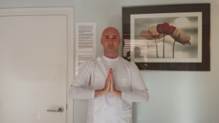
Wrist flexion
Keeping the forearm resting on your thigh, hold a dumbbell (light) or alternatively a tin of food from the cupboards. Keeping the palm facing up, curl your wrist upwards and lower back down in a smooth repetitive pain free motion. Repeat this action for 10-15 repetitions twice. (2x15).
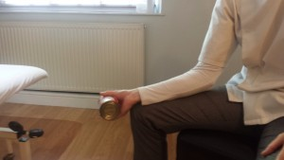
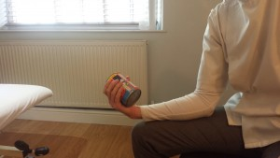

Biceps stretch
Hold the edge of the wall or a door frame with the arm and elbow out straight. Keep your arm in place, and turn your chest away from the arm until a stretch is felt along the biceps of the arm and chest. Then hold for around 30-60 seconds and release slowly. This stretch should be pain free.
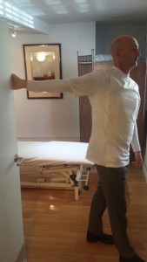
Pronation/supination
With your forearm resting along your thigh whilst Holding an object in the palm of your hand, start with palm facing down or up. Turn the wrist from palm facing down to up, and then back down again. Keep repeating this exercise for 10-15 repetitions in a smooth movement.
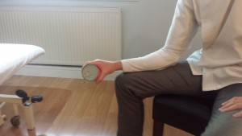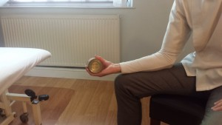
Additional Information
- N.I.C.E (National Institute for Clinical Excellence)
- NHS UK
- Web MD
- Medline Plus
- GOsC (General Osteopathic Council)

*If you are experiencing Elbow pain, feel free to call:
Hazel Grove Osteopathic Surgery on 0161 483 6986 for appointments available Monday - Saturday
302 London road, Hazel Grove, SK7 4RF.

